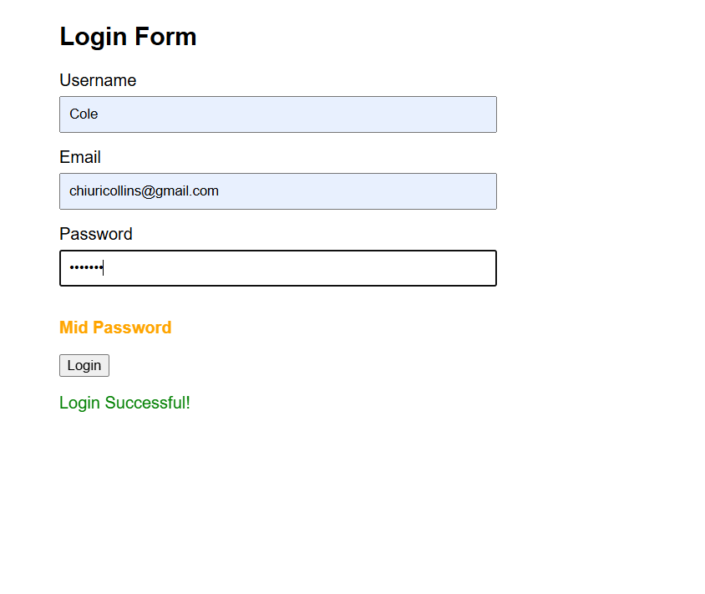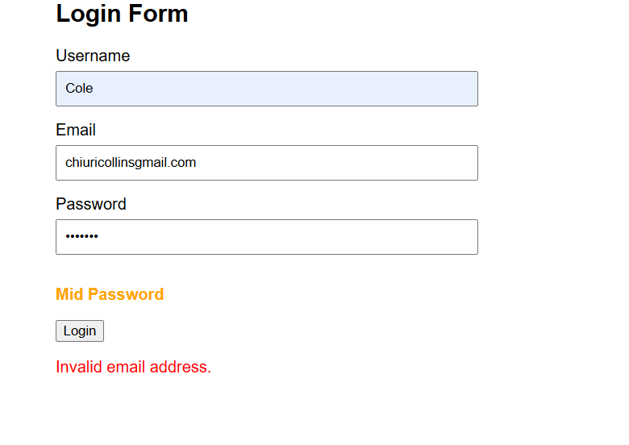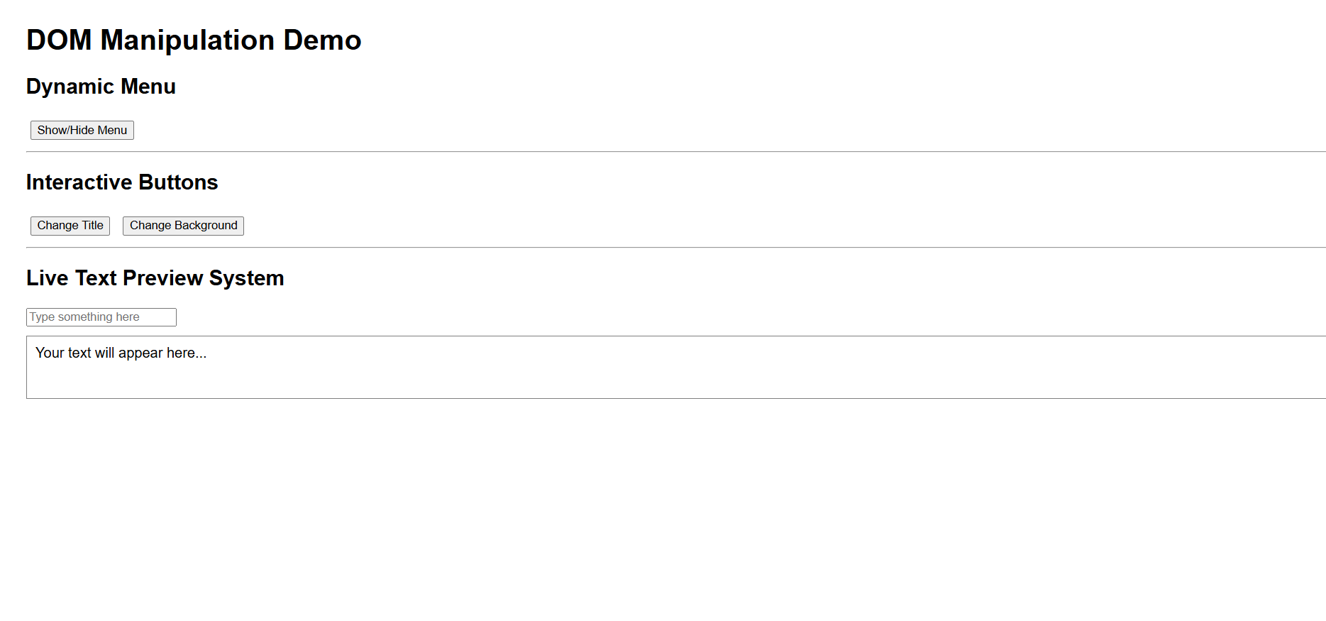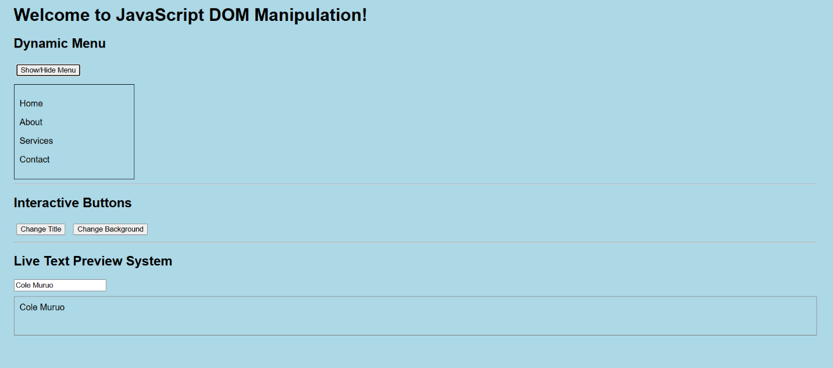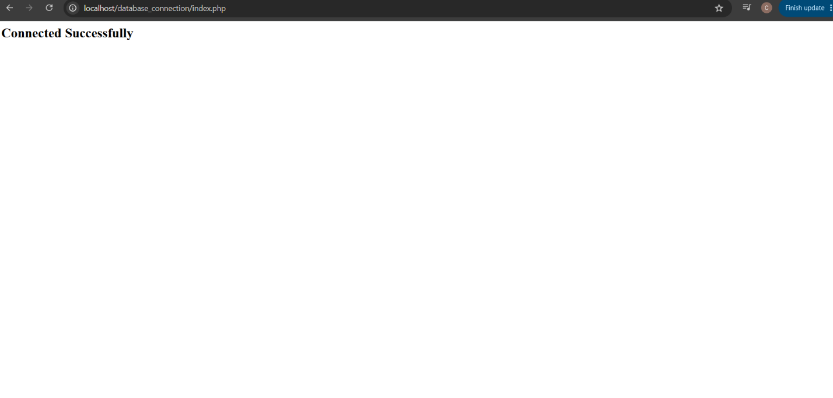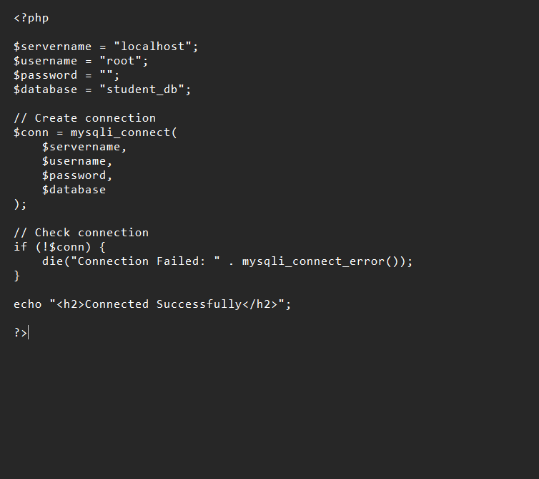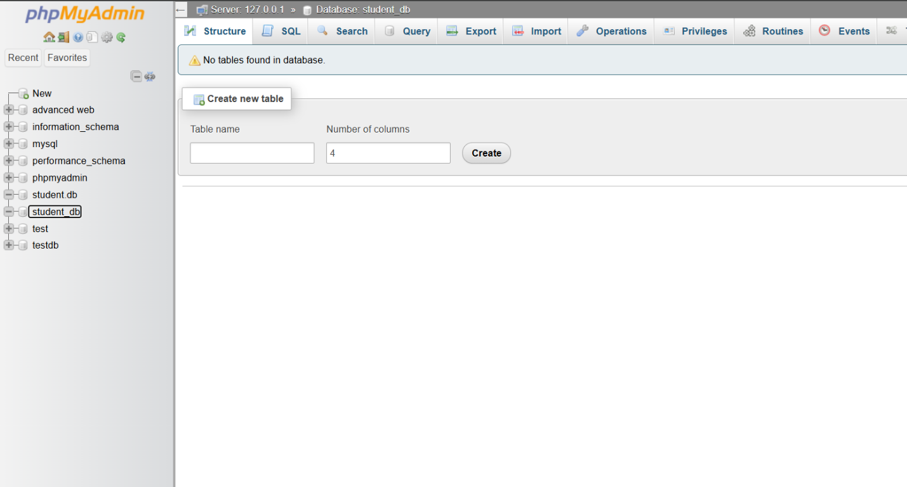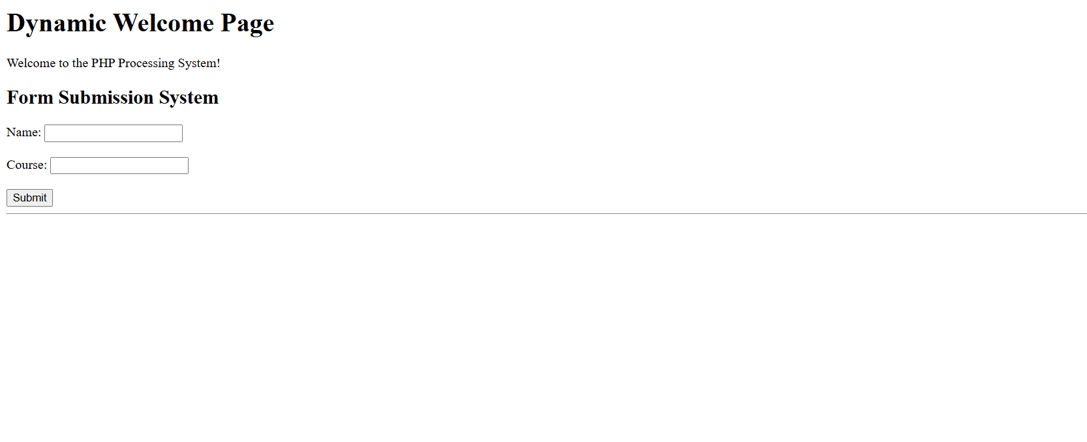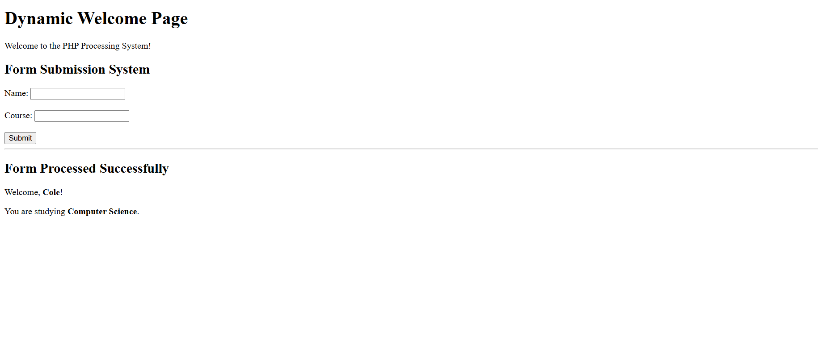

Figure 1 & 2 Password strength check
Figure 3 & 4 Dom manipulation
Figure 5 to 9 PHP Syntax Practice
Figure 10 Database Connection Script
Figure 11 to 14 Dynamic User Input Handling

Lesson
Through this project, I learned that the frontend and backend work together to create a complete web application. The frontend provides the user interface where users interact with the system, while the backend processes requests, performs business logic, and communicates with the database. Validation is important because it ensures that users enter correct and secure data, reducing errors and improving system reliability. Database connections are essential for storing, retrieving, and managing application data efficiently. The technologies used in this project include HTML, CSS, JavaScript, PHP, MySQL, and XAMPP for local development and testing.

